**EXP NO:5B CISCO PACKET TRACER**

**DATE: 16.8.24**

**AIM:** To Design a simple topology using CiscoPacket Tracer

1) 2 SWITCHES, 8PC’s AND ONE ROUTER:

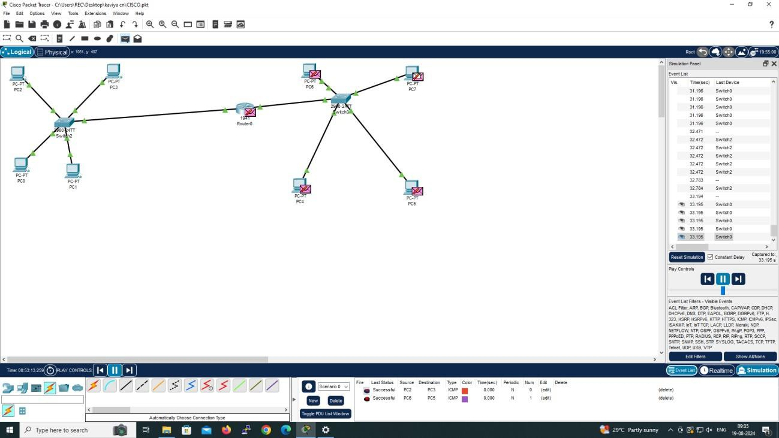

2) 4 PC’s AND ONE HUB:

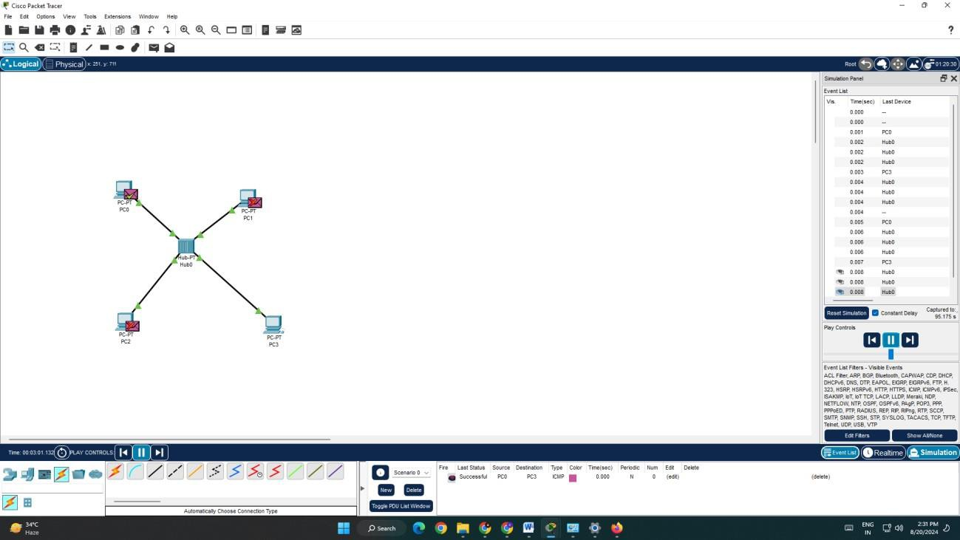

3) 4 PC’s AND ONE SWITCH:

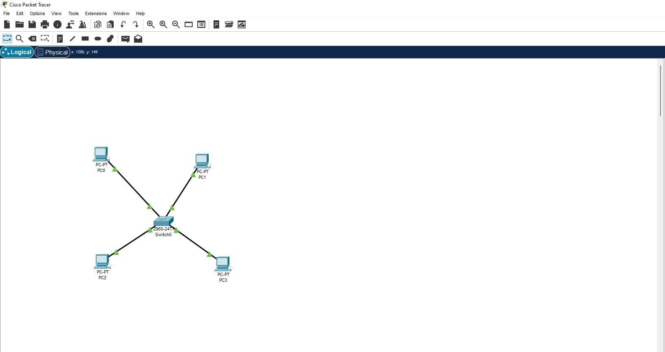

**5) PEER TO PEER CONNECTION:**

